**TUGAS 12**

**MATA KULIAH ALGORITMA DAN DASAR PEMROGRAMAN SEMESTER GENAP TAHUN AKADEMIK 2023-2024**



**Oleh:**

**DEVA FAROIDL**

**4123004**

**PROGRAM STRATA-1 JURUSAN SISTEM INFORMASI**

**UNIVERSITAS PESANTREN TINGGI DARUL 'ULUM JOMBANG**

**2024**

TUGAS 1 :

Source code :

package pkg12;

/**

*

* @author KAMAL

*/

import java.util.ArrayList;

import java.util.List;

public class ContohDaftar {

public static void main(String[] args) {

// Create two ArrayList objects

List<String> warna = new ArrayList<>();

List<String> warnaDihapus = new ArrayList<>();

// Add colors to the "warna" list

warna.add("MAGENTA");

warna.add("RED");

warna.add("WHITE");

warna.add("BLUE");

warna.add("CYAN");

// Add colors to the "warnaDihapus" list

warnaDihapus.add("RED");

warnaDihapus.add("WHITE");

warnaDihapus.add("BLUE");

// Remove colors from the "warna" list that are present in the "warnaDihapus" list

warna.removeAll(warnaDihapus);

// Print the results

System.out.println("Warna : ");

System.out.println(warna);

System.out.println("Warna yang dihapus : ");

System.out.println(warnaDihapus);

System.out.println("Output : ");

System.out.println("Warna : ");

System.out.println(warna);

}

}

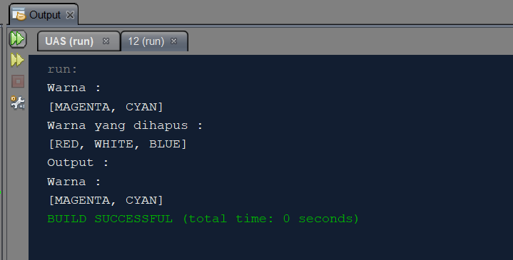

TUGAS 2 :

Soure code :

package pkg12;

/**

*

* @author KAMAL

*/

import java.util.PriorityQueue;

import java.util.Queue;

import java.util.Random;

class Mahasiswa implements Comparable<Mahasiswa> {

private String nrp;

private String nama;

private float nilai;

public Mahasiswa(String nrp, String nama, float nilai) {

this.nrp = nrp;

this.nama = nama;

this.nilai = nilai;

}

public String getNrp() {

return nrp;

}

public String getNama() {

return nama;

}

public float getNilai() {

return nilai;

}

@Override

public int compareTo(Mahasiswa other) {

return Float.compare(other.nilai, this.nilai); // descending order

}

@Override

public String toString() {

return "Mahasiswa{" +

"nrp='" + nrp + '\'' +

", nama='" + nama + '\'' +

", nilai=" + nilai +

'}';

}

}

public class runMhs{

public static void main(String[] args) {

Random random = new Random();

Queue<Mahasiswa> queue = new PriorityQueue<>();

for (int i = 0; i < 10; i++) {

String nrp = "NRP-" + (i + 1);

String nama = "Mahasiswa " + (i + 1);

float nilai = random.nextFloat() * 40 + 60; // random nilai between 60-100

Mahasiswa mahasiswa = new Mahasiswa(nrp, nama, nilai);

queue.add(mahasiswa);

}

System.out.println("Data Mahasiswa sebelum diurutkan:");

for (Mahasiswa mahasiswa : queue) {

System.out.println(mahasiswa);

}

System.out.println("\nData Mahasiswa setelah diurutkan berdasarkan nilai:");

while (!queue.isEmpty()) {

Mahasiswa mahasiswa = queue.poll();

System.out.println(mahasiswa);

}

}

}

